Explain the architecture of your project.
A simplified architecture is:
Angular UI
|
v
FastAPI
|
+----> Document Upload
| |
| v
| Azure Blob Storage
|
+----> OCR
| |
| v
| Extracted Text
|
+----> Azure OpenAI
| |
| v
| Structured Expense Data
|
+----> Validation
|
+----> Fraud Detection
|
+----> Timeline
|
+----> MongoDB
|
v
Embeddings / Vector Search
|
v
RAG
|
v
Azure OpenAI
|
v
Natural Language Answer

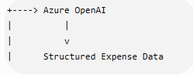
In which part of our project this is happening?
happens primarily in parser_service.py.
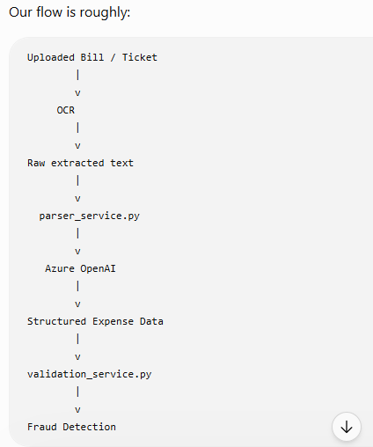

What does parser_service.py do?
For example, an OCR result might look like:
Hotel ABC
Guest: John
Check-in: 10-Sep-2026
Check-out: 12-Sep-2026
Total: USD 450
We send this information to Azure OpenAI with our parsing prompt.
Azure OpenAI converts it into a predictable structure such as:
{
"expense_type": "hotel",
"hotel_name": "Hotel ABC",
"check_in": "2026-09-10",
"check_out": "2026-09-12",
"amount": 450,
"currency": "USD"
}
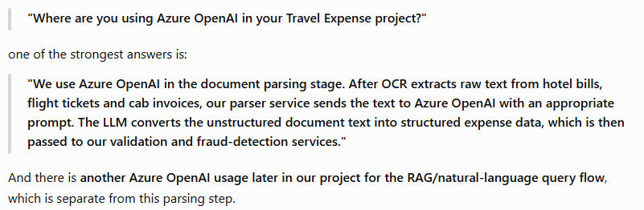

What happens in ocr_service.py
You have:
poller = document_intelligence_client.begin_analyze_document(
"prebuilt-read",
body=image_bytes
)
This is where we actually send the document/image to Azure Document Intelligence.
Suppose the user uploads:
hotel_bill.pdf
Our application first gets the file bytes:
image_bytes
Then:
begin_analyze_document(
"prebuilt-read",
body=image_bytes
)

means approximately:
"Azure Document Intelligence, please analyze these document bytes using the prebuilt-read model and extract the readable text."
So, we are using Azure Document Intelligence to convert the byteArray of image/pdf to readable text(OCR)

What is prebuilt-read?

prebuilt-read is a prebuilt OCR/read model provided by Azure Document Intelligence.
It is designed to read text from documents/images.
For example, imagine the uploaded bill contains:

HOTEL ABC

Guest Name: John Smith
Check In: 10/09/2026
Check Out: 12/09/2026

Room Charge: $400
Tax: $50
Total: $450

Document Intelligence reads the document and gives us the textual information.
So the flow is:
PDF / Image
|
v
Azure Document Intelligence
|
| prebuilt-read
v
Extracted text

Where does Azure OpenAI come into this?
This is where the distinction from your previous question becomes important.
We actually have two different Azure AI services:
Uploaded Bill
|
v
Azure Document Intelligence
prebuilt-read
|
v
Extracted Text
|
v
Azure OpenAI
LLM + Prompt
|
v
Structured Expense Data

Azure Document Intelligence
Its job:
"Read what's written in the document."
Example:
Hotel ABC
Guest: John
Check-in: 10-Sep-2026
Total: USD 450

Azure OpenAI
Its job:
"Understand this text and put the relevant information into our expected structure."
For example:
{
"expense_type": "hotel",
"hotel_name": "Hotel ABC",
"guest_name": "John",
"check_in": "2026-09-10",
"amount": 450,
"currency": "USD"
}

"Are you using Azure OpenAI for OCR?"
I would answer:
"No. We use Azure Document Intelligence with the prebuilt-read model for OCR and text extraction. We then pass the extracted text to Azure OpenAI, where the LLM interprets the text according to our prompts and converts it into structured expense data."
What is Pydantic?
Pydantic is a Python library used for data validation and defining structured data models.
When we write:
class FlightTicketData(BaseModel):
we are saying:
FlightTicketData is a Pydantic model, and its data must follow the structure defined below.
For example:
class FlightTicketData(BaseModel):

travelerName: Optional[str] = None
departureCity: Optional[str] = None
flightNumber: Optional[str] = None
travelDate: Optional[str] = None
This defines a schema roughly like:
{
"travelerName": "John Smith",
"departureCity": "Kolkata",
"flightNumber": "AI123",
"travelDate": "2026-09-20"
}

Why is this useful with Azure OpenAI?
Because an LLM is generating the information.
We don't want to simply trust that the LLM will always return exactly the structure we expect.
Pydantic gives us a defined structure and validation.

Optional — very important
You have:
travelerName: Optional[str] = None
Let's break this down.

str
Means:
If a value is provided, it should be a string.
For example:
travelerName = "John Smith"

Optional[str]
Means:
This field can contain a string OR None.
So these are valid:
travelerName = "John Smith"
and:
travelerName = None

= None
This gives the field a default value.
So if the document doesn't contain the traveler's name, we can have:
{
"travelerName": null
}
instead of the parser failing simply because the field wasn't available.

Literal — restricts the allowed values
Now look at:
from typing import Literal, Optional
and:
class FlightParseResult(BaseModel):

documentType: Literal["FlightTicket", "Unknown"]
Literal means:
This field can only contain one of these specifically allowed values.
So:
documentType = "FlightTicket"
is valid.
And:
documentType = "Unknown"
is valid.
But:
documentType = "HotelInvoice"
would not be valid for FlightParseResult.

What is Field(default_factory=...)?
You have:
data: FlightTicketData = Field(
default_factory=FlightTicketData
)
This is a Pydantic feature.
It says:
If data isn't supplied, create a new FlightTicketData object as the default.
In other words, instead of:
data = None
we can have an empty:
FlightTicketData()
which gives us the defined fields with their defaults.
Why did you use Pydantic in your project?
"We use Pydantic models to define and validate the expected structured output from our document parser. Azure Document Intelligence first extracts the raw text, and Azure OpenAI interprets that text and produces structured flight or hotel information. The Pydantic models define the expected fields and their data types, helping us maintain a consistent contract before passing the data to our validation and fraud-detection services."
And if they specifically ask Optional vs Literal:
"Optional allows a field to contain a value or None, which is useful because real-world documents may not contain every field. Literal restricts a field to a predefined set of values—for example, our documentType can be FlightTicket or Unknown."

